Chem Extra Credit
Laura Brown
Cholesterol
Cholesterol is fat, that your body needs to. It is a waxy substance found in the cells of our body. This vital fat is important for brain function, the brain contains 25% of the cholesterol found in the human body. Furthermore, cholesterol helps with cell membrane function, acts as an antioxidant, is a building block for steroid hormones, aids in digesting food, and builds vitamin D after sun exposure.
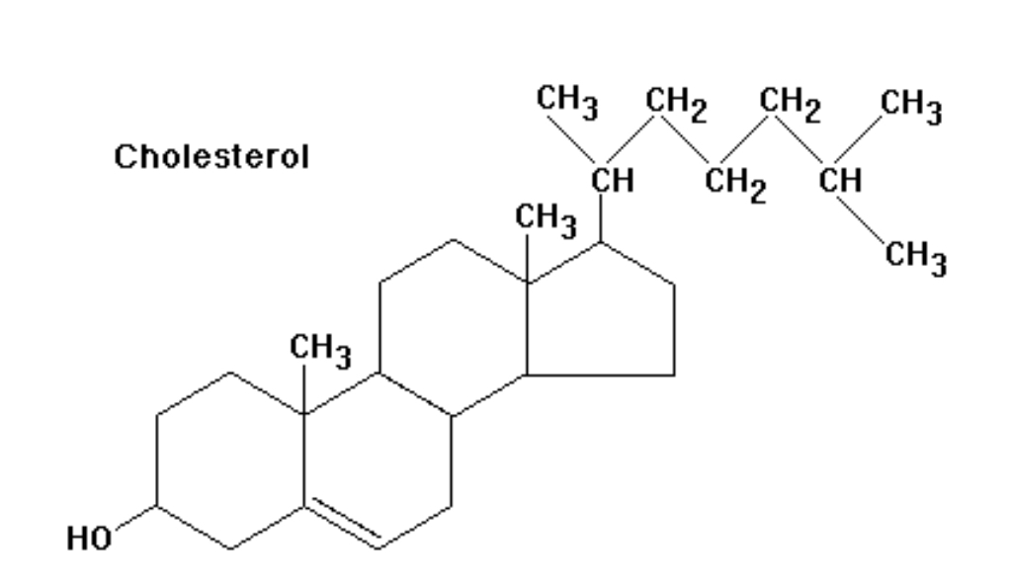www.precisionnutrition.com
The liver is the main star in creating cholesterol from the food we eat. It produces 1-2 grams per day, this varies based on whether or not we are eating cholesterol rich foods. Some of these foods include the wonderful egg, butter, meats, coconut oil, Grass fed beef and chicken, dark chocolate. Bad cholesterol comes from canola/processed vegetable oils, packed/processed food, sugar, alcohol, processed meats, dairy, and refined grain products.
There are two types of cholesterol High Density Lipoprotein (HDL-good) and Low Density Lipoprotein (LDL- “bad”). HDL absorbs cholesterol by converting it to cholesteryl esters and transporting it back to the liver and flush it out of the body. LDL makes up the majority of our bodies cholesterol. LDL carries cholesterol to cells, and our cells need LDL in order to maintain proper function. LDL is taken up by endocytosis, the lipoprotein is broken down, and the cholesterol is free from the esters to be utilized by the cell. LDL really isn’t the issue and that is where the general population is confused. The problem happens when the carrier protein (LDL) becomes damaged and oxidized. This then turns on inflammation in the immune system that causes issues like coronary artery disease. We can keep LDL from oxidizing by eating good fats and eating less carbohydrates.
The lower cholesterol the higher risk for dementia. Studies have shown that low cholesterol is associated with an increased risk of depression, alzheimer's, and overall brain issues (https://www.drperlmutter.com/war-on-cholesterol/). Cholesterol technically isn’t the issue, inflammation is. When we eat bad food our inflammation skyrockets we we develop leaky gut, leaky brain, brain fog, mood disorders, parkinson's disease (can be increased with very low levels of LDL), heart disease, diabetes, autoimmune disorders, ADHD, anxiety, the list goes on and on. Function medicine leader Dr. Hyman says, “naturally occurring fats in our whole foods aren’t the problem. Refined, processed fats and oils that are added to our food by the food industry are.” Food is not supposed to promote disease it exists to provide us with energy, to heal and repair our bodies, and keep disease away. However, we have gotten so far away from healthy whole food diets we have created a storm of issues and a population that doesn't understand the health benefits of fat. The food you eat is either fighting or promoting disease.

